Sharing of Joys and Concerns
The Lord’s Prayer

Our Father, who art in heaven, hallowed be thy name. Thy kingdom come, Thy will be done on earth as it is in heaven. Give us this day our daily bread and forgive us our trespasses, as we forgive those who trespass against us. And lead us not into temptation, but deliver us from evil. For thine is the kingdom, and the power, and the glory, forever. Amen.
*Singing Our Faith #2142 (TFWS) (vs. 1, 4, & 5) “Blessed Quietness”
*Blessing and Dismissal
*Postlude

Scatter to Serve God & Neighbor

Welcome to all! We gather to praise God for the innumerable blessings given to us and to grow deeper in the Spirit. Joyfully, let us lift our hearts to God.

DIRECTORY OF CHESTNUT HILL UNITED METHODIST CHURCH
Adam J. White | Minister
Sharon Mayhew | Director of Music
Monica Campbell | Administrative Assistant
Judy Martin | Bookkeeper
Judy Robertson  Elizabeth Nichols | Lay Leader  Missionary in Henry County


C hestnut Hill
United Methodist Church

Making disciples of Jesus Christ
for the transformation of the world.
You are welcome at Chestnut Hill UMC.

4660 Fort Avenue ~ Lynchburg, Virginia 24502
Church: 434-239-8423
Minister’s Cell: 434-944-7723, Minister’s Email: awhite@ves.org
Email: chestnuthillumc@comcast.net
On the Web at chestnuthillumc.net
Find us on Facebook: Chestnut Hill United Methodist Church

Chestnut Hill United Methodist Church

10:30 a.m. ~ June 7, 2026 ~ Second Sunday after Pentecost
Our ministry vision for the Virginia Annual Conference is “to be
disciples of Jesus Christ who are lifelong learners, who influence others to serve.”

Welcome! Join us in worshiping God!
Prelude
Welcome and Ministry Announcements Linda Jessen
Welcome in the name of Christ our Lord. Please register your attendance, printing your name, address, phone, and email, on the attendance pad provided on your pew. Thank you for silencing cell phones as we gather to worship God.
Invocation
*Greeting
Let me hear what God the Sovereign will speak,
For God will speak peace to the people,
God will speak to the faithful,
To those who turn to God in their hearts.
Surely God's salvation is at hand for those who fear God,
that God's glory may dwell in our land.
Steadfast love and faithfulness will meet,
Justice and peace will intermingle,
God will give what is good,
and our land will yield its increase.
Justice will go before God,
and will make a path for God's steps.
*Singing Our Faith #2128 (TFWS) “Come and Find the Quiet Center”

Opening Prayer
Blessed are you who begin again. You who resist the pressure to overhaul your entire life in a weekend. Who picks one underwhelming thing and say: “This. I can do this. Probably.” Blessed are we, the slow changers, hungry for all

that makes life good, but exhausted by the thought of what it might take to get there. We who want to pause long enough to ask: Is this mine to do? And can I do it without becoming completely unbearable? For we are the back-to-school grownups trying again, with a commitment to One Reasonable Thing. That probably won’t fix us, but hope to make us more loving, and less prone to raging at people in the car. More compassionate, and less impatient. More attuned to the good, and less enslaved by the “should.” May these small habits help us become. Not our best selves. But faithful, present and less cranky by dinner. May we be open to all that God is doing in us and through us. And maybe, just maybe, we will change. Slowly. Faithfully. All with the help of God. (Kate Bowler)

Special Music by G. Croly & F. Atkinson

“Spirit of God, Descend upon My Heart”

Greeting Friends and Neighbors

Prayer of Illumination Linda Jessen
Living God, help us so to hear your whole Word that we may truly understand; that, understanding, we may believe, and believing, we may follow in all faithfulness and obedience, seeking your honor and glory in all that we do through Christ our Lord, Amen.
Scripture Lesson Hebrews 12:22-29 Linda Jessen
The Word of God for the people of God.

Thanks be to God.
Singing Our Faith #2156 (TFWS) (Sing 3 times.) “Give Peace”
The Good News “Unshakable” Erin Long
Bringing Forward God’s Tithes and Our Gifts
*Doxology # 95 Praise God from whom all blessings flow; praise him, all Creatures here below; praise him above, ye heavenly host; praise Father, Son, and Holy Ghost. Amen.
*Prayer of Thanksgiving

**Calendar **
Tuesday, 6/9 | 7:00 p.m. | Homeschool Game Night
** Looking Ahead on the Calendar **
Sunday, 6/14 | 10:00 a.m. | Choir
Monday, 6/15 | 7:00 p.m. | Wesleyan Group @ Jane White’s home.
Thursday, 6/18 | 10:30 a.m. | Merry Martha’s Circle  Lunch to follow at Charley’s.

Virgina Annual Conference ~ June 17-20
Atlantic Union Bank Center
James Madison University
Harrisonburg, VA
GRADUATES
Graduation is upon us. Let the church office know if you, or a
family member, will be graduating this year. You can call us at 239-8423 or email us at chestnuthillumc@comcast.net.

Birthdays Coming Up: June 8-Vernelle Roupe, 11- Alice Lovelace, 12-Frances Unruh, 15- Dan Robertson,
20-Scottie Nuckols, 21-Sue Norvelle
For the Grocery Cart:
June ~ Chunky Soups, Fruit/Vegetable Canned Goods. Pop-top.

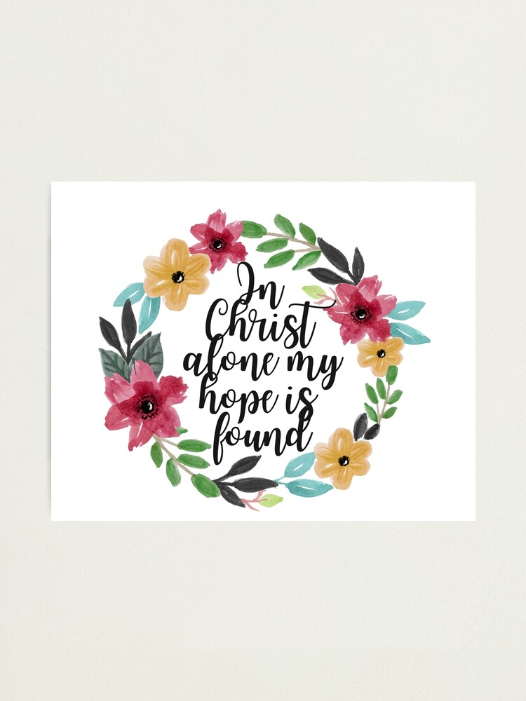

**Calendar **
Tuesday, 6/9 | 7:00 p.m. | Homeschool Game Night
** Looking Ahead on the Calendar **
Sunday, 6/14 | 10:00 a.m. | Choir
Monday, 6/15 | 7:00 p.m. | Wesleyan Group @ Jane White’s home.
Thursday, 6/18 | 10:30 a.m. | Merry Martha’s Circle  Lunch to follow at Charley’s.
Virgina Annual Conference ~ June 17-20
Atlantic Union Bank Center
James Madison University
Harrisonburg, VA
GRADUATES
Graduation is upon us. Let the church office know if you, or a
family member, will be graduating this year. You can call us at 239-8423 or email us at chestnuthillumc@comcast.net.
Birthdays Coming Up: June 8-Vernelle Roupe, 11- Alice Lovelace, 12-Frances Unruh, 15- Dan Robertson,
20-Scottie Nuckols, 21-Sue Norvelle
For the Grocery Cart:
June ~ Chunky Soups, Fruit/Vegetable Canned Goods. Pop-top.

